**If you want to hacking wordpress using linux**

1. You can import kali linux on vm

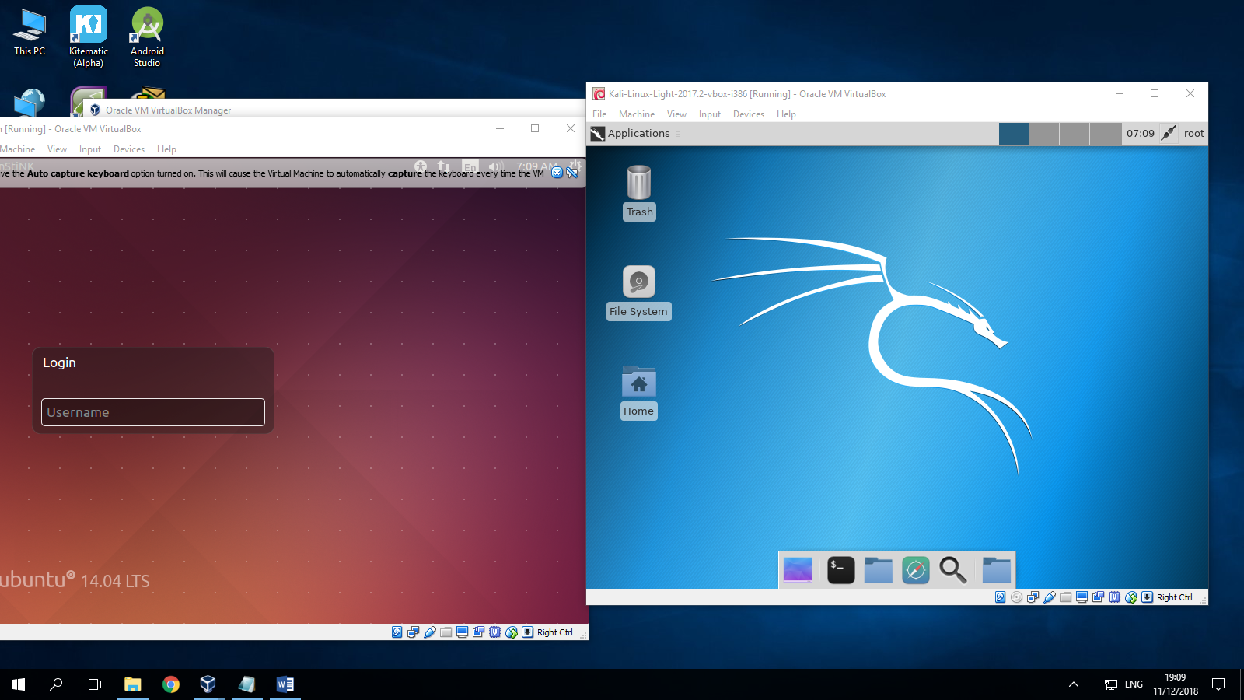

1. You can import Ubuntu linux on vm

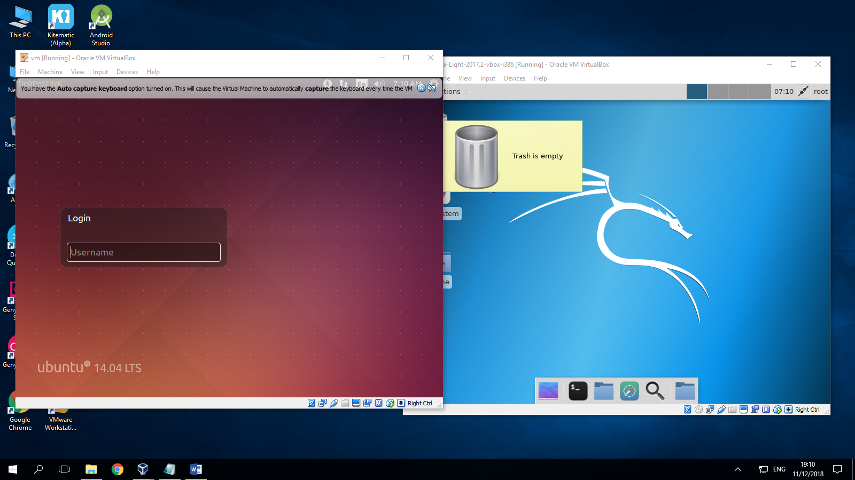

1. You can setting network Ubuntu linux

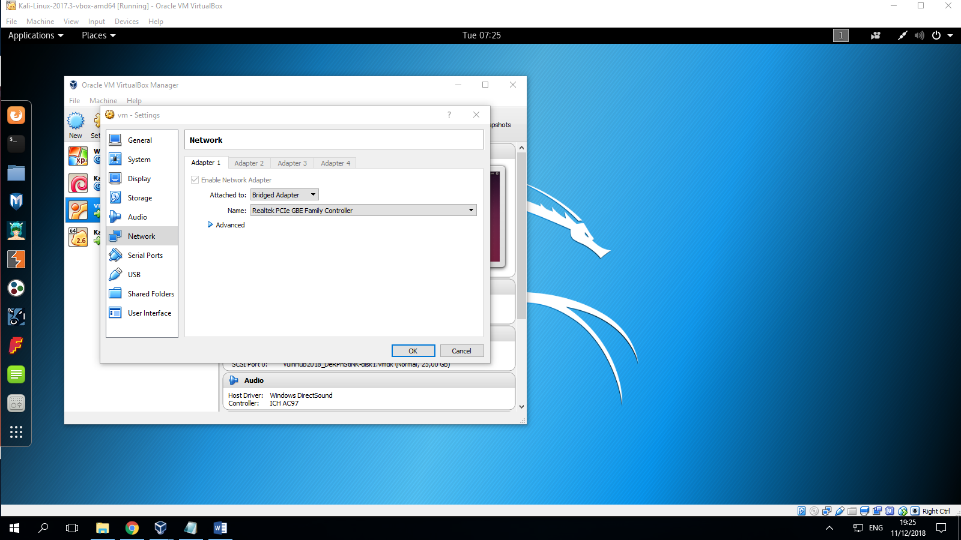

1. You can scanning ip target using command “**arp-scan –l --interface=eth1**” because we can get ip your computer

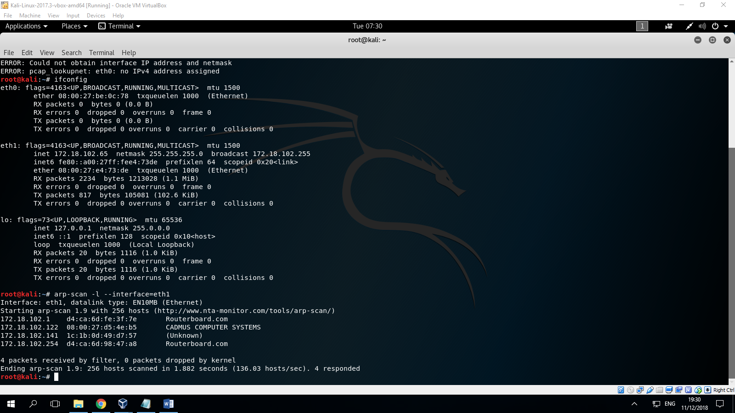

1. You can running nmap command “nmap -sC -sV -p- -v -oA nmap ip-addr”

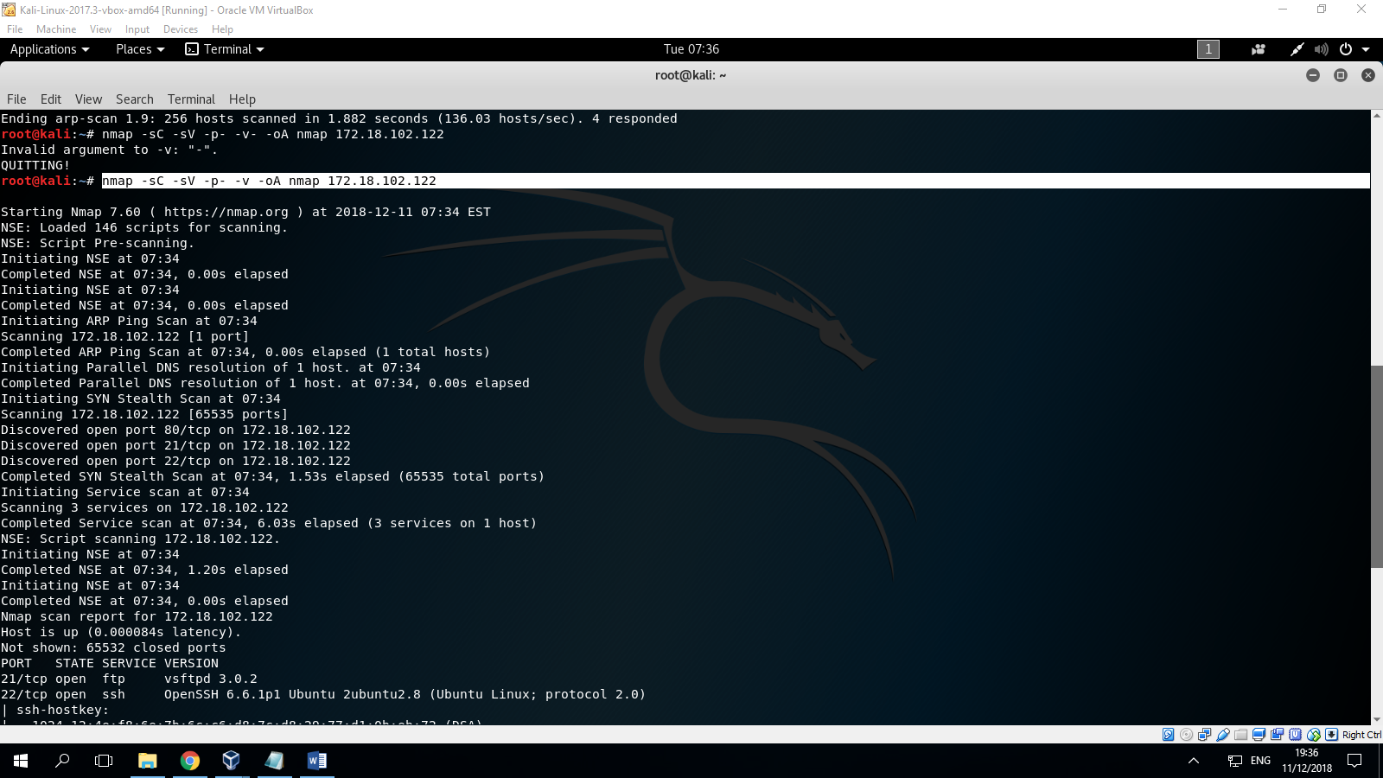

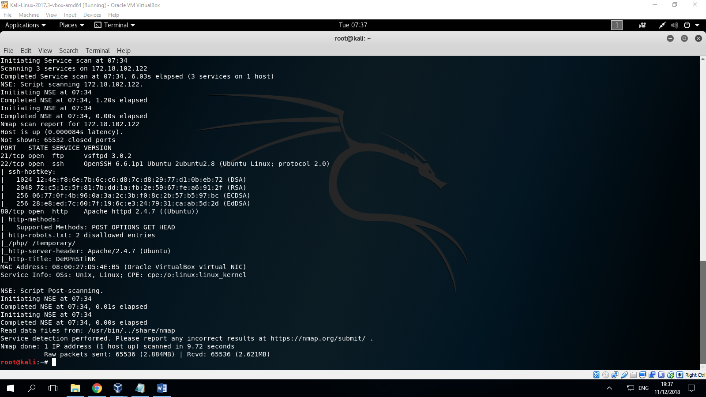

1. You cand typing command “dirb http://ipaddr”

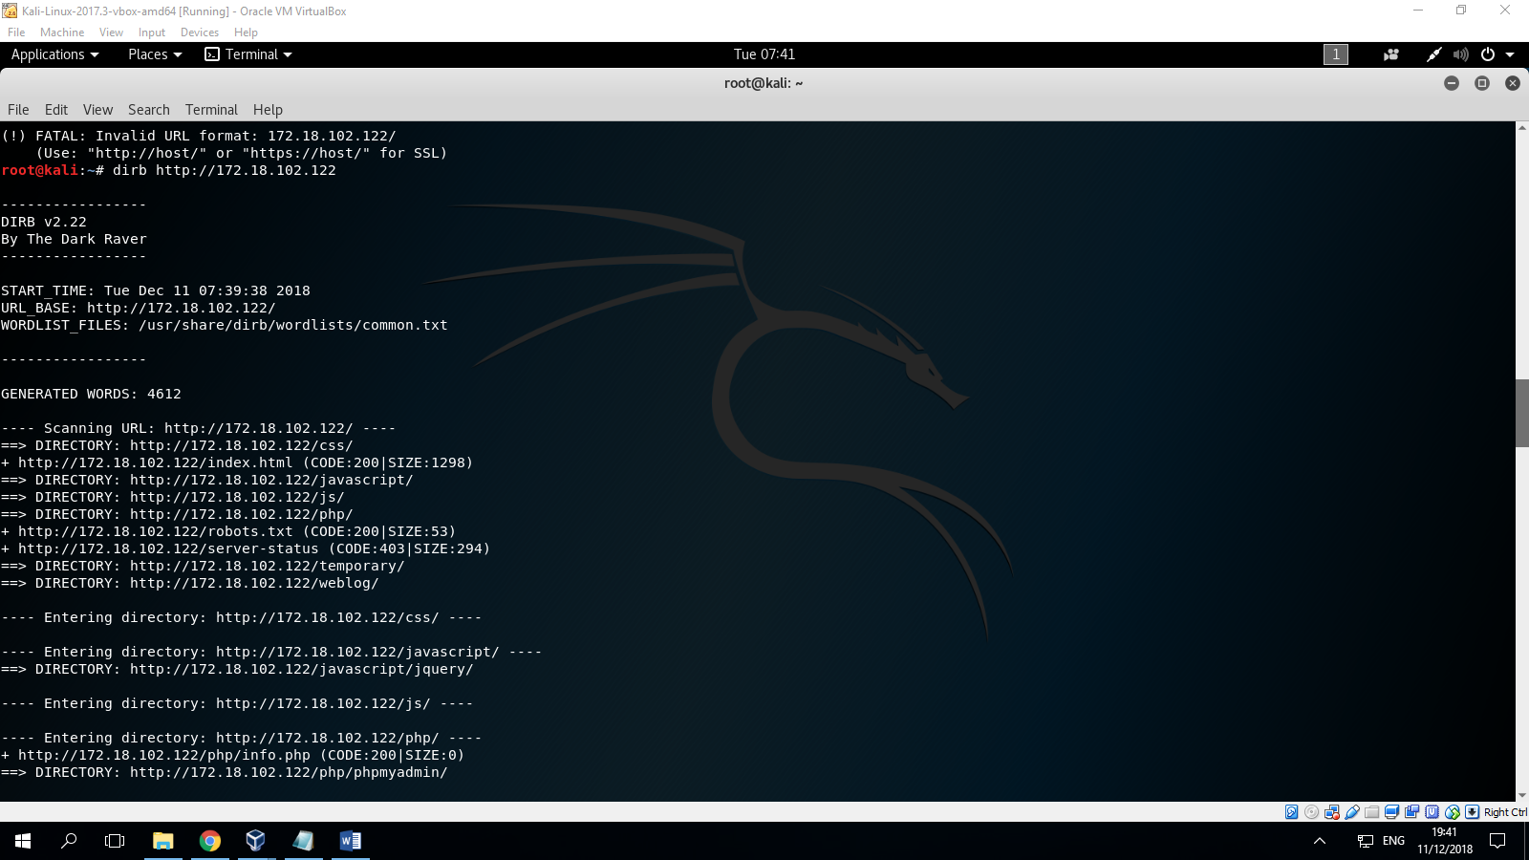

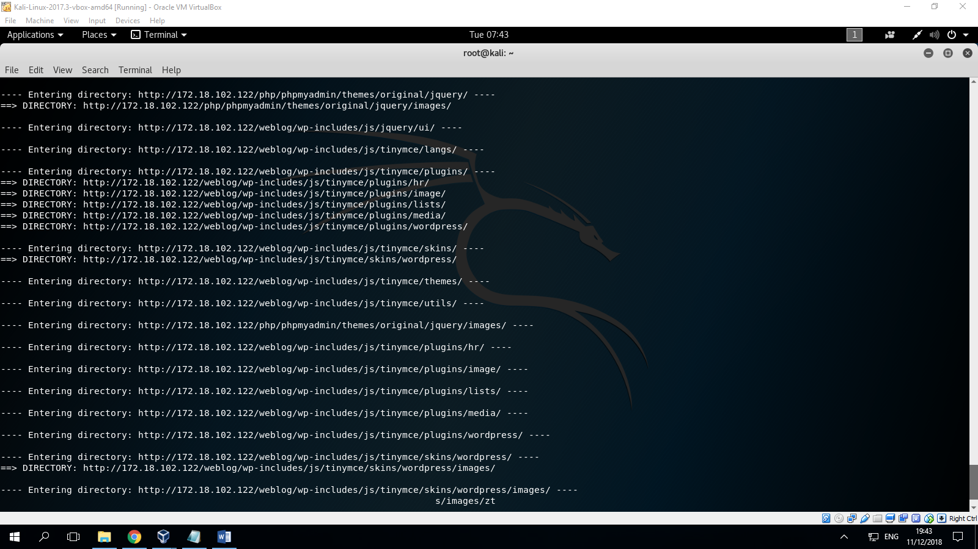

1. You can typing direktories “pico /etc/hosts” and typing ip your target

